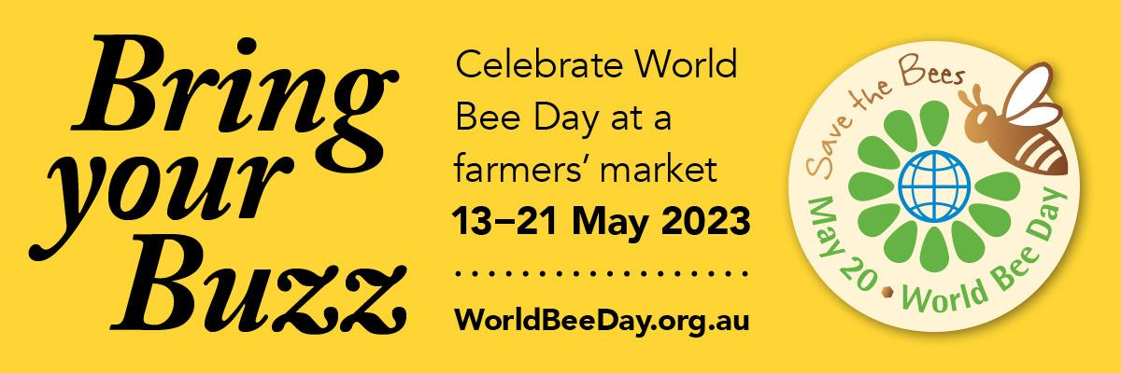

World Bee Day 2023
Australian Farmers’ Markets Association Communications Toolkit
April 2023
Introduction
Australian Farmers’ Markets Association and Wheen Bee Foundation are joining forces to celebrate World Bee Day from 13-21 May,
to raise awareness of the important role bees play in food production.
Celebrating World Bee Day
Bring your Buzz – 13-21 May 2023
A campaign in the lead-up to World Bee Day to encourage people to wear yellow to their local farmers’ market to celebrate the important role bees play in food production, and the important, bee-friendly role farmers’ markets play in the food supply chain.
This Communications Toolkit contains:
- Key messages and facts to be used when speaking about World Bee Day and the Bring your Buzz campaign
- Bring your Buzz social media tiles and example social media posts to share the message
- Bring your Buzz newsletter copy and newsletter banners
- Bring your Buzz posters for use in farmers’ markets
- We need bees posters
- We need bees social media tiles
- Free event listing link on the World Bee Day website
- Media release on Bring your Buzz and World Bee Day, to tailor to individual markets to provide to local media outlets
Key messages
- This year’s World Bee Day theme is ‘Bee engaged in pollinator-friendly agriculture’.
- Australian Farmers’ Markets Association and farmers’ markets across the country are proud to celebrate World Bee Day.
- Wear yellow to your local farmers’ market to show your support for the important role bees play in food production.
- Shop at a farmers’ market, one of the most bee-friendly ways to buy your fresh fruit and vegetables, honey and even your morning coffee, all of which depend on bees.
- We need bees. Bees play a vital role in food production and healthy diets. Two-thirds of our food production relies on bees.
- There are things you can do to support bees: Buy organic. Support initiatives that increase habitat for pollinators, improve bee ecosystems. Become a Bee Friendly Farmer. Become a Bee Friendly Farming Gardener
What you can do to help raise awareness for World Bee Day
and encourage people to celebrate at their local farmers’ market
You can help by:
- Sharing social media posts about the Bring your Buzz campaign, to encourage people to wear yellow to a market from 13-21 May
- Printing a Bring your Buzz poster for your farmers’ market or individual market stall promoting the Bring your Buzz campaign
- Sharing the Bring your Buzz campaign information in your farmers’ market newsletter

- Sharing social media posts about World Bee Day and the We need bees campaign, to raise awareness of the importance of bees
- Printing a World Bee Day and the We need bees poster for your farmers’ market or individual market stall
- Sharing World Bee Day and We need bees campaign information in your farmers’ market newsletter

- Share this World Bee Day Communications Stakeholder Pack with anyone who might like to use the posts or posters
- Add the hashtags #bringyourbuzz, #worldbeeday, #farmersmarkets4bees #farmersmarketsbuzz to any of your related social posts

Free event listing on World Bee Day Australia
All farmers’ markets taking part in the Bring your Buzz campaign or any other World Bee Day activities are encouraged to list their event for free on the World Bee Day Australia website. Events listed will be promoted across World Bee Day and Wheen Bee Foundation channels.
Add your farmers' market listing here

Links to websites
www.worldbeeday.org.au
www.wheenbeefoundation.org.au
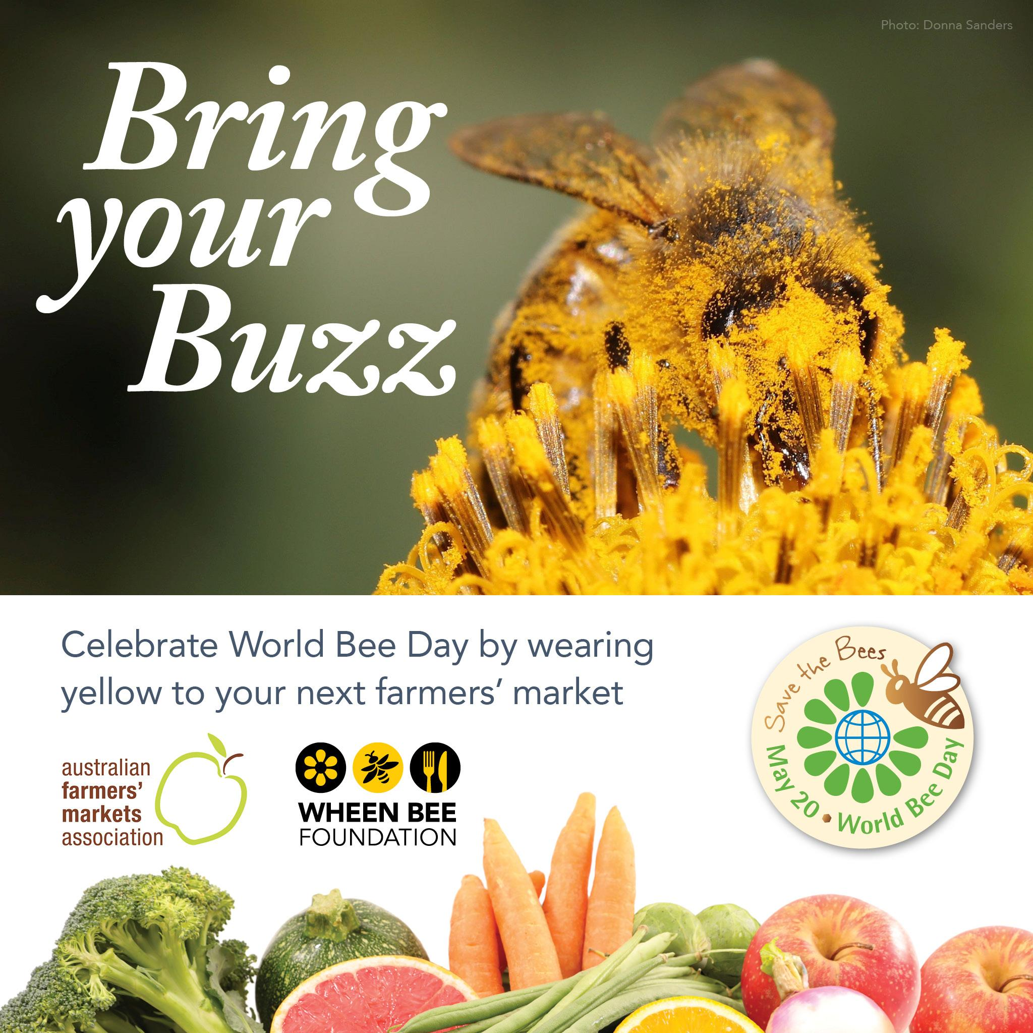
Social media
The following copy can be used with the Bring your Buzz socials tiles (right):
Download the social tiles here
Example copy:
Wear yellow to your local farmers’ market between 13-21 May to celebrate World Bee Day
and show your support for the important role bees play in food production.

Visit www.worldbeeday.org.au for more information
#bringyourbuzz #worldbeeday @WorldBeeDayAustralia @wheenbeefoundation
Or
Shopping at a farmers’ market is one of the most bee-friendly ways to buy your fresh fruit
and vegetables, honey and even your morning coffee, all of which depend on bees.
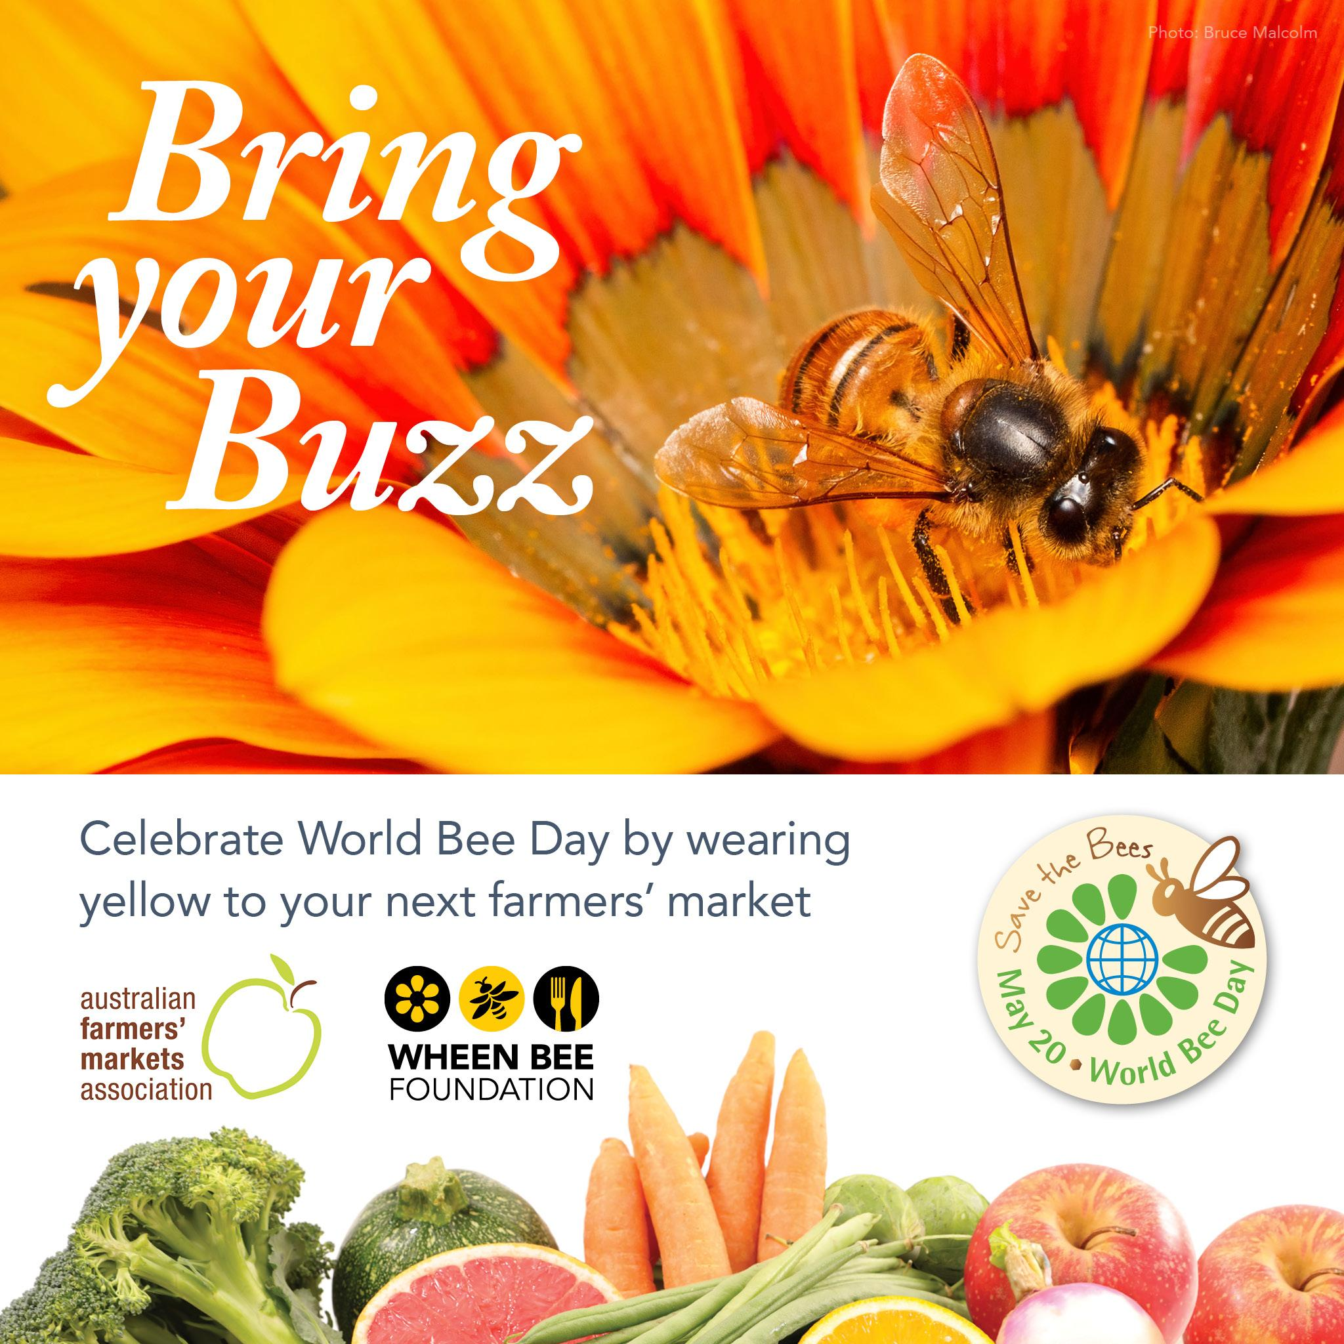
So wear yellow to your local farmers’ market between 13-21 May to celebrate World Bee Day
and show your support for the important role bees play in food production.
Visit www.worldbeeday.org.au for more information
#bringyourbuzz #worldbeeday #farmersmarketsbuzz #farmersmarkets4bees
@WorldBeeDayAustralia @wheenbeefoundation
Facebook
www.facebook.com/WorldBeeDayAustralia, @WorldBeeDayAustralia
Instagram
https://www.instagram.com/world_bee_day_australia/
Newsletter copy
The following copy can be used in newsletters or EDMs, with newsletter banner (right)
Download the newsletter banner here
Newsletter copy for market managers to send to stallholders to inform them of the Bring your Buzz campaign:
How to celebrate World Bee Day 2023
Australian Farmers’ Markets Association and farmers’ markets across the country
are celebrating World Bee Day at any market held from 13-21 May.
AFMA farmers’ market stallholders can promote the Bring your Buzz campaign, encouraging customers to visit their local farmers’ market from 13-21 May and wear yellow to celebrate World Bee Day and show their appreciation for the important role bees play in food production.
There are social media posts, newsletter materials and posters for stallholders to share.
To request a communications pack, email {insert farmers’ market manager email here}.
For more information visit www.worldbeeday.org.au

Newsletter copy for stallholders to insert in newsletters to customers to
inform them of the Bring your Buzz campaign
Celebrate World Bee Day at your local farmers’ market
Next month, the {insert market name here} is celebrating World Bee Day on {insert date here}.
World Bee Day raises awareness of the important role bees play in food production and healthy diets. Two-thirds of our food production relies on bees.
Shopping at a farmers’ market is one of the most bee-friendly ways to buy your fresh fruit and vegetables, honey and even your morning coffee, all of which depend on bees.
So come and visit us on {day} and wear yellow to show your appreciation for bees.
For more information visit www.worldbeeday.org.au
Bring your Buzz posters
These posters can be used in farmers’ markets and stalls. They are available in A3 and A4.
Download the Bring your Buzz posters here

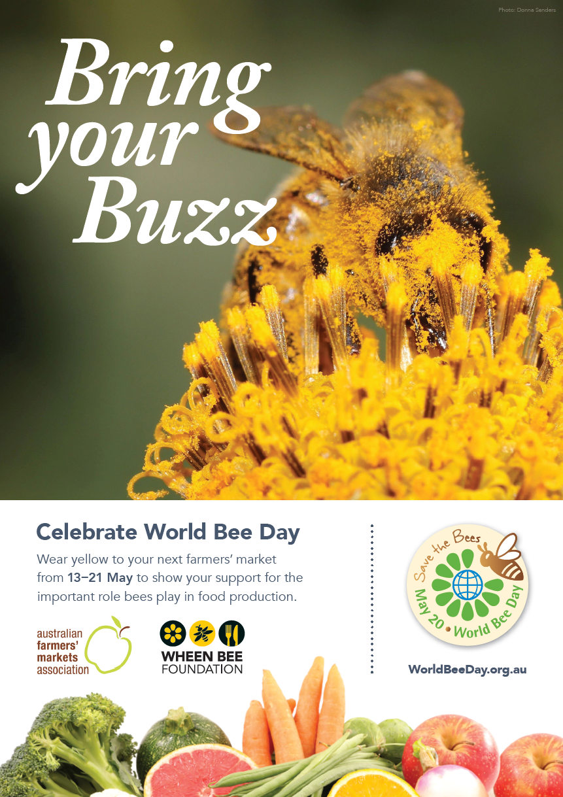
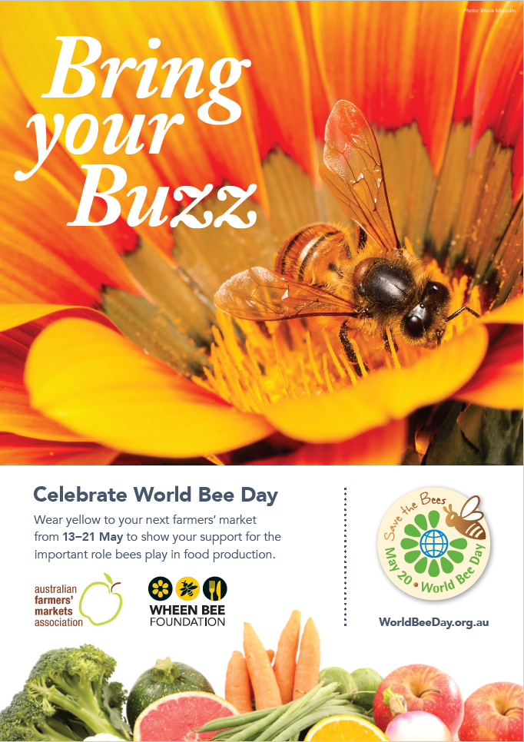
We need bees Posters and Social tiles
This poster can be used in farmers’ markets and stalls to provide more information on why it’s important to celebrate bees. It’s available in A3 and A4. Social media tiles are also available to share on socials.
Download the We need bees posters here
Download the We need bees social tiles here
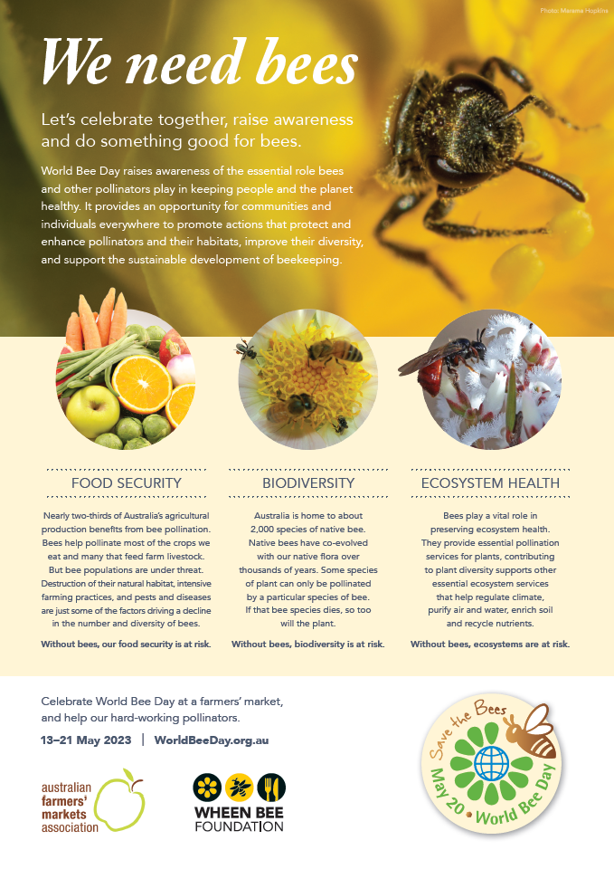

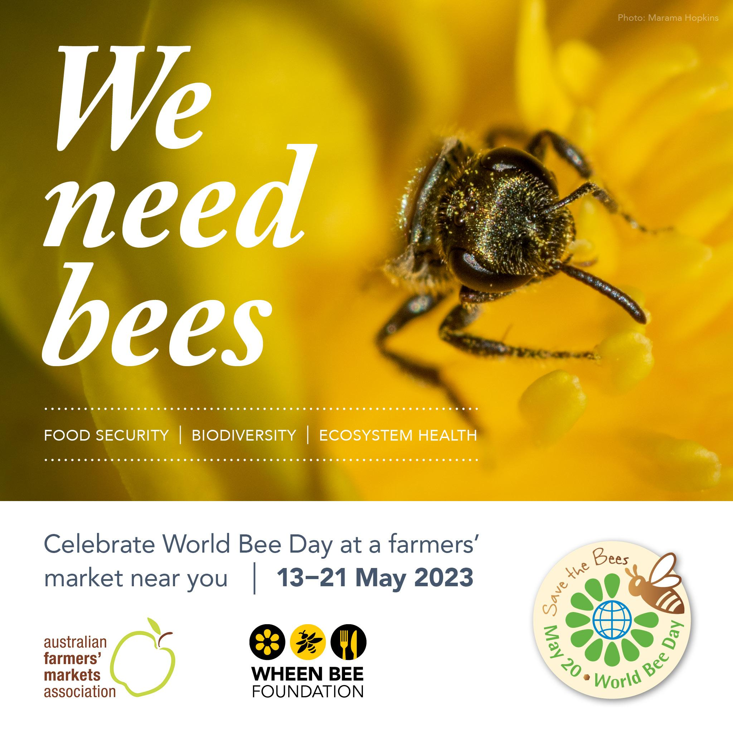
List your event for free at World Bee Day Australia
All farmers’ markets taking part in the Bring your Buzz campaign or any other World Bee Day activities are encouraged to list their event for free on the World Bee Day Australia website.
Market events listed will be promoted across World Bee Day and Wheen Bee Foundation channels in the lead-up to the markets.
Registration is simple –
- Click on the link below to go directly to the event listing site
- Provide your email address and a password and you are ready to list your event.
Add your farmers' market listing here

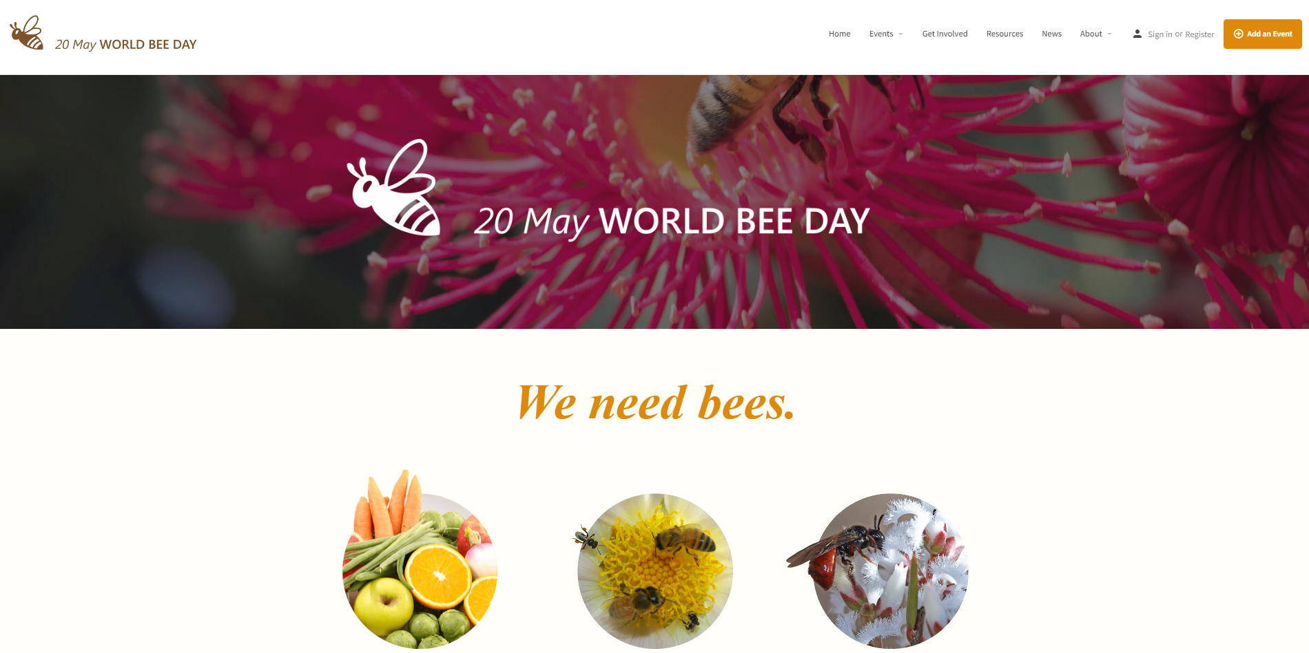
Media release
The following media release can be tailored to suit your farmers’ market and provided to local media.
START
Date here Embargoed until Monday 24 April 2023
Farmers’ markets shine yellow to support agriculture’s hardest little workers

[Insert market name here] is preparing for a buzzy market day on [insert market date in May here] as farmers, food producers and shoppers don their favourite yellow garb to celebrate World Bee Day on 20 May, 2023.
This year’s World Bee Day theme is ‘Bee engaged in pollinator-friendly agriculture’, and there’s no better way for people to celebrate than to join the Bring Your Buzz campaign, wearing yellow to their local farmers’ market to highlight the vital role pollinators play in our food production systems.
The Bring Your Buzz campaign is a joint venture between Australian Farmers’ Markets Association and the Wheen Bee Foundation.
Australian Farmers’ Markets Association Chairperson Jane Adams says markets across the country are excited to support World Bee Day 2023 with its global theme highlighting pollinator-friendly agriculture, with festivities running at farmers’ markets across the country from Saturday 13 May to Sunday 21 May.
“Encouraging stallholders and visitors to wear their yellow hats, beanies, scarves and hoodies is a simple, fun way our vibrant farmers’ market network can support healthy food systems and healthy communities,” Ms Adams said.
“We hope to see yellow bags and baskets, dog collars and stall signs all helping to create a buzz and raise awareness.”
Ms Adams says farmers’ markets are the perfect place for non-farmers to embrace this year’s World Bee Day theme that encourages people to become engaged in pollinator-friendly agriculture.
“Farmers’ markets support sustainable food production by supplying local, seasonal produce,” Ms Adams said. “Shopping at your local farmers’ market is a great way to support farmers who in turn support bees.”
Wheen Bee Foundation CEO Fiona Chambers said this year’s World Bee Day theme was a timely reminder for people to actively seek out farmers and agriculture businesses that place a priority on supporting pollinators and the vital service they provide in putting food on our tables.
“Engaging in pollinator-friendly agriculture means managing the land in a way that helps pollinators thrive,” Ms Chambers said. “Farmers can plant pollinator-friendly plants to increase places for bees to forage, live and breed and avoid pesticides that cause harm to bees.”
“And there are lots of ways for people in urban areas to get involved as well,” Ms Chambers said. “Anyone can plant a bee-friendly garden or veranda pots or buy produce from farmers who are dedicated to supporting pollinators.”

For more information on World Bee Day visit worldbeeday.org.au
For more information on [insert market name here] visit [insert website details here]

END

